

# Week Seven Lab Work

# Networking Infrastructure / International Development Conditions

# Network Calculation Tasks

Perform an investigation and establish the current network infrastructure supported in Ireland.

We have discussed previously how Ireland is a Greenhouse and Hub for a substantial amount of Cloud Providers, this in turn would not be possible without certain pre-requisites.

During your investigation of Ireland Network infrastructure additionally establish some of the reasonings behind the popularity of Ireland for Cloud Service Providers and major international companies establishing a Head Quarters on the island of Ireland.

1. **Explain the current Irish Telecommunications Network infrastructure, the following points can be used to structure your study**
   1. Historical Context
   2. Recent Developments – Articles / Papers / News Items
   3. Current Coverage – Is Fibre available every where
   4. Current Investments
   5. Ownerships and stakeholders
   6. Previous / Historical Complications or Issues
   7. Main Providers of telecommunication services in Ireland e.g Vodafone Broadband

 A: Ireland's telecoms are undergoing a significant transformation. Once dominated by Eircom (now Eir) in a monopoly that stifled innovation (pre-1990s), deregulation in the 1990s opened the door for competition.

Now, the government is heavily invested in the National Broadband Plan (launched in the 2010s) aiming to deliver high-speed, quality, affordable broadband services to all premises in Ireland, with a focus on closing the gap in underserved rural areas. Fibre networks are expanding, led by companies like Eir, enet, and Vodafone offering 1Gbps services in many areas, but full nationwide coverage isn't there yet (as of March 2024).

Mobile networks are run by Eir Mobile, Three, and Vodafone, with MVNOs offering additional options. While historical limitations like Eircom's monopoly are being addressed, challenges like affordability and complete network build-out remain.

**Aligning with the EU's 5G Vision**

This transformation aligns with the European Union's Digital Strategy, particularly the "Europe's 5G strategy in the Digital Decade" initiative launched in 2021. This strategy emphasizes achieving widespread 5G coverage across all populated areas by 2030. To meet this goal, Ireland is focusing on building a high-speed backbone for low-latency 5G networks and investing in research and development to drive innovation in 5G technologies.

By aligning with the EU's vision, Ireland aims to become a leader in the European 5G landscape, fostering economic growth and technological advancement.

References:

<https://nbi.ie/>

<https://ireland.representation.ec.europa.eu/strategy-and-priorities/key-eu-policies-ireland/europe-fit-digital-age_en>

<https://www.comreg.ie/>

1. **Give reasoning and your own understanding as to why Ireland is a popular Hub for international companies to “Setup” here in Ireland.** 
   1. Provide 3-4 points and a description of your reasoning, typical subcategories include taxation and Populus.

Why Ireland is a Hub for International Companies: A Mix of Tax and Talent

A: Ireland has become a magnet for international companies looking to expand their operations in Europe. Here are three key reasons, along with my understanding of their impact:

**Favourable Tax Environment:** Ireland boasts a corporate tax rate of just 12.5%, one of the lowest in Europe. This significantly reduces the tax burden for companies compared to their home countries, which can translate to higher profits or more competitive pricing. It's a clear financial incentive for businesses seeking a cost-effective European base.

**Skilled and Adaptable Workforce:** Ireland has a well-educated population with a strong emphasis on science, technology, engineering, and mathematics (STEM) fields. This young and adaptable workforce creates a readily available pool of talent for international companies, especially those in tech and innovation sectors. A skilled workforce is crucial for these businesses to thrive and compete globally.

**English-Speaking Country with EU Access:** Being the only English-speaking country in the Eurozone offers a distinct advantage. Companies can leverage the ease of communication and cultural familiarity within Ireland, while simultaneously gaining access to the wider European market with minimal language barriers. This simplifies operations and reduces potential roadblocks for international expansion.

These factors combine to create a very attractive proposition for international companies. The lower tax rate offers a clear financial advantage, while the skilled workforce ensures they have the talent needed to succeed. Additionally, the ease of doing business in an English-speaking, EU-member country eliminates many potential hurdles often associated with international expansion.

1. Using the below illustration establish the following

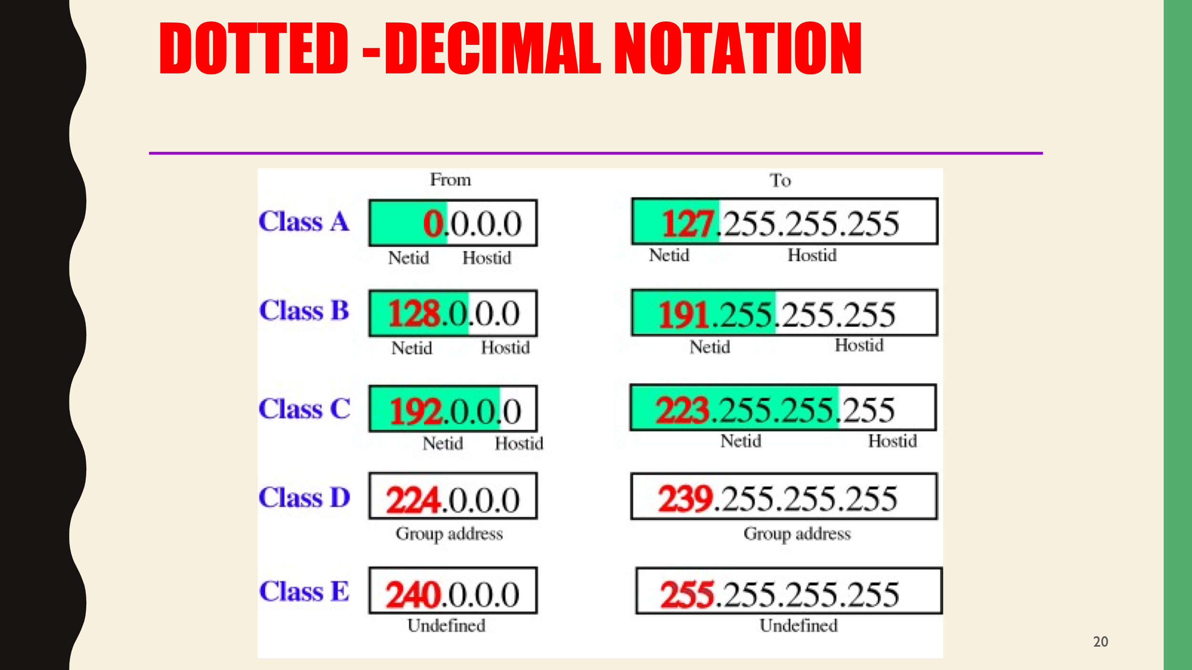

* **Find the class of the following IP addresses.**
* **208.34.54.12 - C**
* **238.34.2.1 - D**
* **114.34.2.8 - A**
* **129.14.6.8 - B**

Upon successfully Identification of the classes of each address above establish the NetID and HostID of the above IP “InternetProtocals” Addresses.

1 – (208.34.54) - Net ID, (12) – HostID

2 - 238.34.2.1 – Class D are reserved and do not have hostIDs

3 – (114) NetID. (34.2.8) Host ID

4 – (129.14) NetID, (6.8) – HostID

1. Establish your current network speed using an online network speed identifier.
   1. Examples of such services:
      1. <https://www.speedtest.net/>
      2. <https://broadbandspeedtest.ie/>
      3. <https://www.eir.ie/support/broadbandspeedtest/>

The above examples give you the ability to change your destination tester, typically Dublin, change this variable and identify any changes in the network speed. Attempt to burden the network with multiple tabs or a large download and identify any changes in network speed.

Additionally, if you are connected through ethernet change to wifi connection and identify if any a degradation in speed achieved. Example Below.

How does the speed results differ based upon e.g the destination being Pinged / the Medium being used / the burden on the network / the device being used ?

Using server in another continent

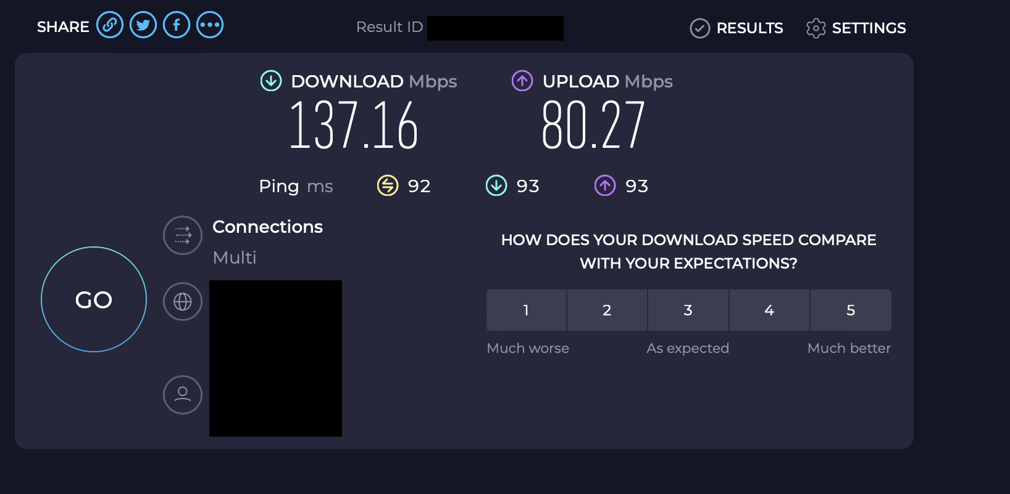

Using server in Dublin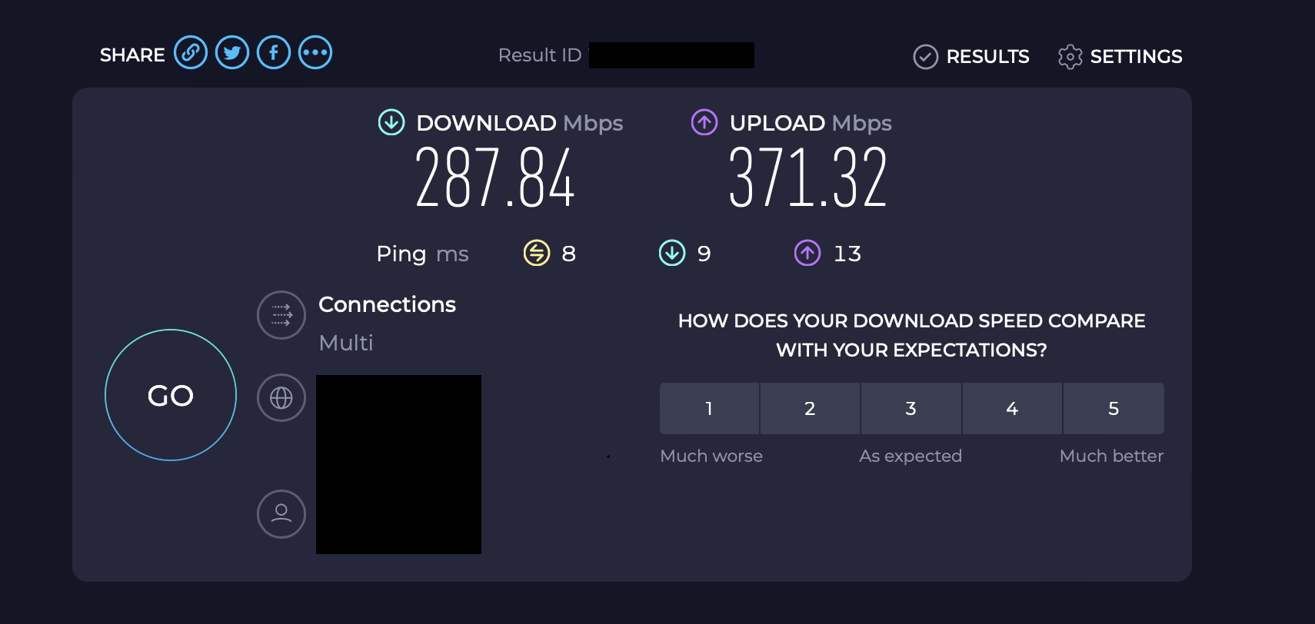

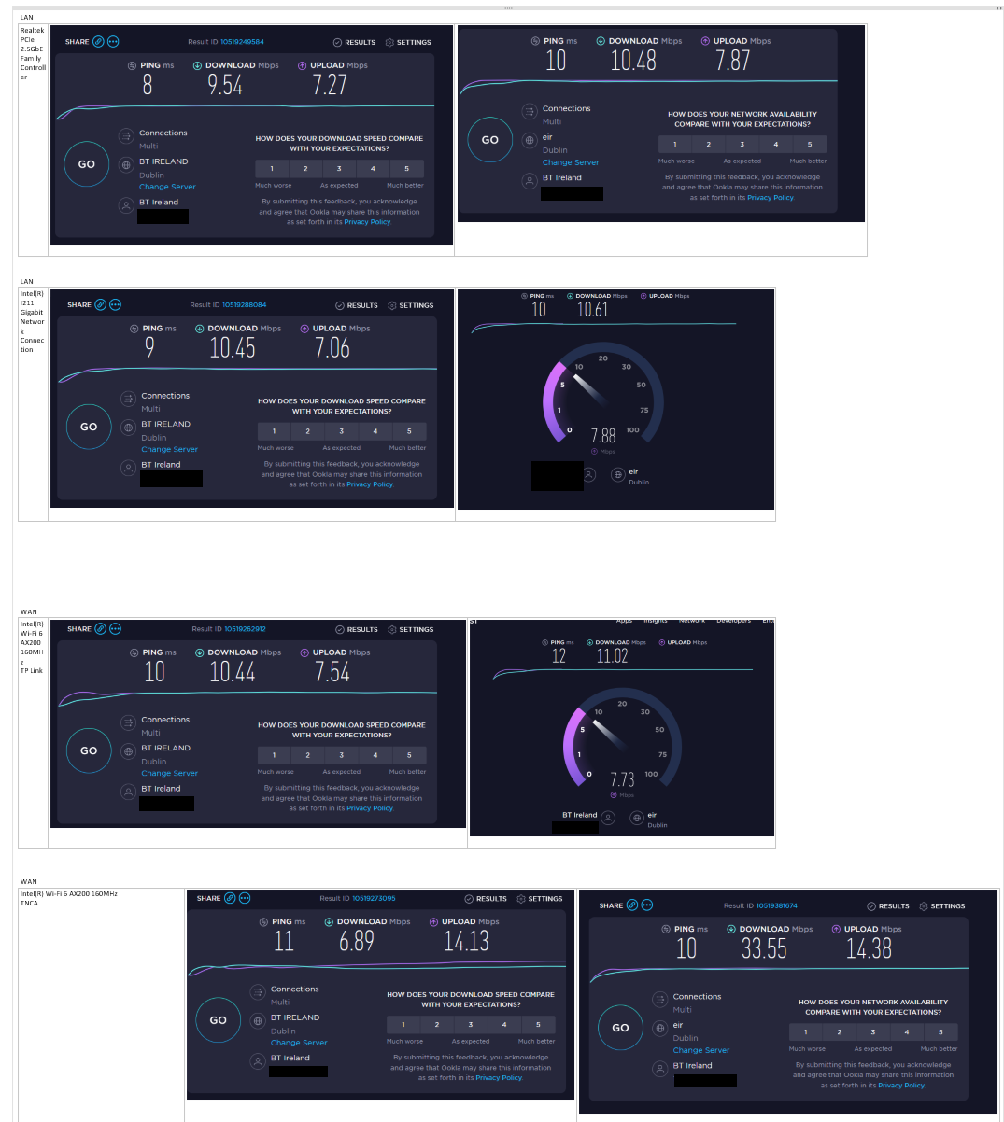

Figure 1Tests Performed using Ethernet & Wifi also different Connections and Connection Hardwares

Compare your results to the above. Ensure to hide your ip if providing screenshots as seen above.

If you need to provide screenshots , no only for CAOSN but for other modules , I recommend the snipit tool from windows and then using Paint.Net a free useful tool. <https://www.getpaint.net/>